Program Flow Chart

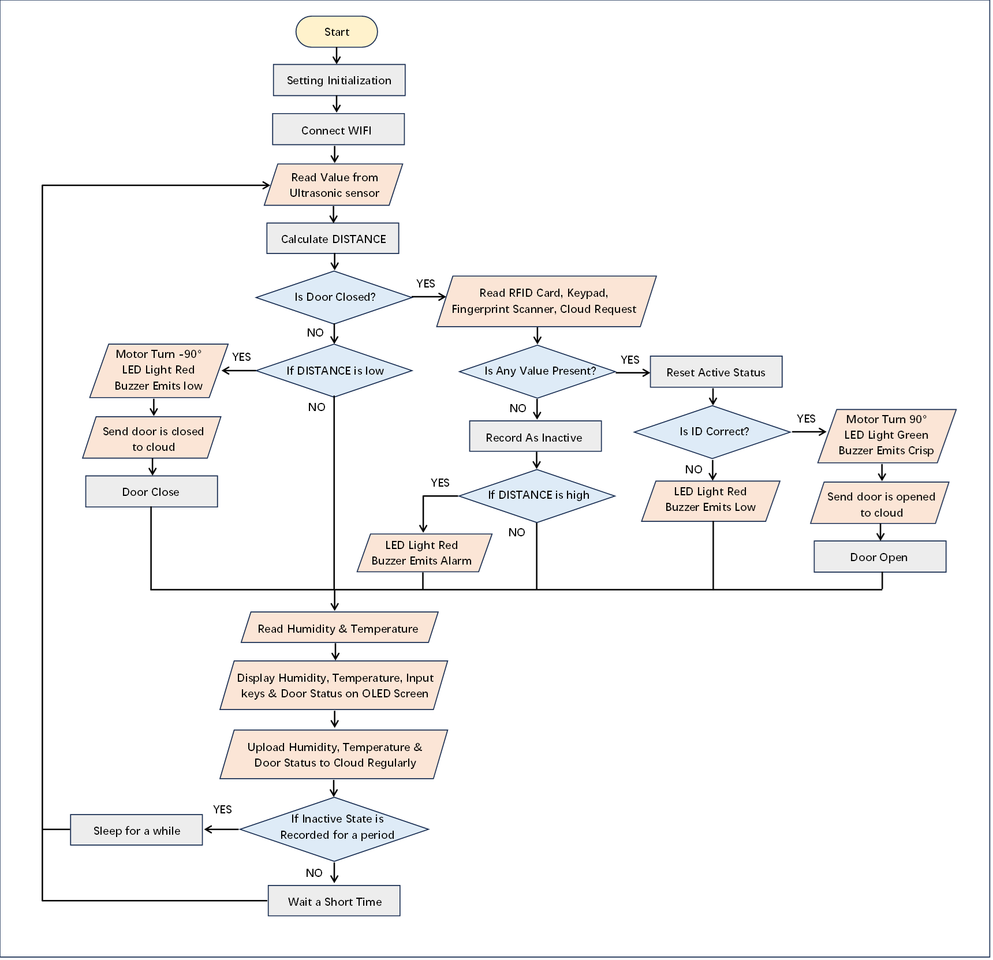

**Read Value from Ultrasonic sensor**

**Calculate DISTANCE**

**YES**

**Start**

**Setting Initialization**

**Connect WIFI**

**Is Door Closed?**

**NO**

**YES**

**Read RFID Card, Keypad,**

**Fingerprint Scanner, Cloud Request**

**Is Any Value Present?**

**NO**

**Reset Active Status**

**Is ID Correct?**

**YES**

**NO**

**Motor Turn 90°**

**LED Light Green**

**Buzzer Emits Crisp**

**Send door is opened to cloud**

**Door Open**

**LED Light Red**

**Buzzer Emits Low**

**Record As Inactive**

**If DISTANCE is low**

**YES**

**Motor Turn -90°**

**LED Light Red**

**Buzzer Emits low**

**Send door is closed to cloud**

**Door Close**

**NO**

**NO**

**If DISTANCE is high**

**LED Light Red**

**Buzzer Emits Alarm**

**YES**

**Read Humidity & Temperature**

**Display Humidity, Temperature, Input keys & Door Status on OLED Screen**

**Upload Humidity, Temperature &**

**Door Status to Cloud Regularly**

**NO**

**If Inactive State is Recorded for a period**

**YES**

**Wait a Short Time**

**Sleep for a while**